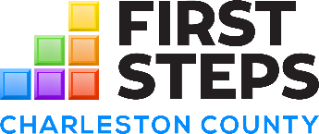

PARTNERSHIP ANNUAL BOARD MEETING
September 9, 2025

Agenda

- Call to Order
- Welcome / Introductions
  - Establish Quorum

- Approval of Agenda
- Motion –September Agenda

- Consent Agenda Items
- Board Meeting Minutes – 7.29.25
- Standing Committee Reports
      - Program Committee – No Report
      - Finance & Audit Committee – No report
      - Development & Fundraising Committee – No report
      - Executive Committee – 6.3.25 & 6.20.25
- Executive Director Report – Report submitted
(Highlights and/or updates will be provided in agenda item below)
- Motion – Approve Consent Agenda Items A - C above, which have been previously submitted
for board member review

- Action Items
- Election of Officers
  - Motion – Adopt elected officers as presented
- Finance Report
- Motion – Approve finance report as presented
- FY26 Staff Professional Development Opportunities
  - Motion – Approve FY26 Staff request to attend the presented professional development and conference opportunities
- Board Retreat & Employee Handbook – Saturday, October 25 or November 1st
  - Motion – Approve proposal as presented

- Discussion Items
- Executive Director Updates
- Community Needs Survey
- Next meeting – December 9th at 5:30pm

- Motion to Adjourn

REMINDER:
Notes: Full Board quorum: 7 | Exec. Committee quorum: 3
This meeting was held in compliance with FOIA and ADA. Approved meeting minutes are available for public
view at our office. Board meetings are open to the public.

Mission:
The Charleston County First Steps mission is to improve the overall well-being of young children. We accomplish this by offering rigorous early childhood programming, providing opportunities for family engagement and support, and fostering community partnerships.

Vision:
All children in Charleston County will be healthy and successful in school.

